**Quantify trade-offs between number of steady bug flow days and hydropower revenue for Glen Canyon Dam**

**Moazzam Rind**

**Utah State University**

**October 14, 2020**

**Main Points**

1. Quantify an ecosystem objective in a way that directly speaks to the ecology of aquatic invertebrates: the number of days in the month with low flow that invertebrates can lay and hatch eggs.
2. Show tradeoffs between two competing objectives -- number of low flow days and hydropower revenue -- for scenarios of monthly release volume and energy pricing.
3. With existing energy prices, steady flows on weekends generates the maximum total monthly revenues. Each added steady weekday will deduct almost $62,750 from monthly hydropower revenues.
4. Each 0.1 MAF increase in monthly release volume generates $2.25 million of additional hydropower revenue.
5. Energy price differential between on- and off-peak periods controls the slope of tradeoff curves.
6. If hydro system capacity becomes limited on a weekday scheduled for steady low releases, dam operators can increase releases and dramatically increase hydropower revenue. The increased revenue can fund two or more weekdays of low releases later in the month.
7. Identify multiple release hydrographs that generate the same hydropower revenue and number of days of steady flows. These multiple strategies give managers flexibility.

**Introduction**

Aquatic insects make a major part of the river food web (Kennedy et al., 2016). Specifically, in the Grand Canyon, both native and non-native fish populations compete for the available food. For that reason, researchers and water managers are looking for reservoir release hydrographs suitable for both ecosystem and hydropower objectives. This report answers the questions for Glen Canyon Dam management: what is the tradeoff between monthly hydropower revenue and the number of days with steady low flows that aquatic invertebrates can lay and hatch eggs? And how does the tradeoff vary with monthly release volume and energy pricing scenarios?

The document describes a sub-daily linear programming model to quantify the tradeoffs. The model was validated with observed flow and energy generation data from 2018. The model was tested for multiple monthly release volumes and energy price differential scenarios. Water managers, hydropower generation and marketing companies, environmental groups, and local stakeholders can use the model to test scenarios of releases and pricing schemes and to estimate their impacts on total monthly hydropower revenue generation. Equally, the model can be helpful for testing different numbers of steady low flow days and quantify their impacts on monthly hydropower revenues.

**Literature Review**

Kennedy et al. (2016) used a nonlinear metric called the “Hydropeaking Index”, which is a ratio of amount variation in release to average release, to represent ecosystem objective. Their calculations include daily hydropeaking index averaged over a period of at least 5 years for 16 dam sites across the Western United States. They found that hydropeaking has a negative influence over aquatic insect diversity (EPT %). Specifically, large dams e.g. Hoover dam, Glen Canyon dam, etc. had a high hydropeaking index and almost no insect diversity. They suggested low steady weekend reservoir releases can improve the situation for aquatic invertebrates, because bug-eggs laid during stable low weekend releases will have minimum chances of desiccation. In addition, energy demand on weekends is relatively less (Førsund, 2015), therefore, replacing hydropeaking operations with steady flows on weekends would minimally affect the total hydropower revenues (USBR, 2016).

Typically, a hydropower objective is a non-linear function (Yoo, 2009) that depends on the power generation release, reservoir storage level, turbine efficiencies, and operations in relationship to design efficiencies. Those releases to generate hydropower fluctuate through the day according to varying energy prices. Commonly, dynamic programing has been preferred to solve such problems because of multiple sub decisions required to reach the ultimate optimal decision (e.g. Yakowitz, 1982; Ko et al., 1992; Tilmant et al., 2002). These nonlinear optimization problems are more computationally intensive than linear problems (Hochbaum, 2007). Because of the computational challenges, researchers have interest to approximate nonlinear objectives by various linearization techniques.

For example, Rheinheimer et al. (2015) developed a linear programming model to maintain downstream cold water temperatures for Chinook salmon below Lake Spaulding, California. They considered that the reservoir has two completely mixed thermal layers (i.e. warm and cold pools) and the release decisions were made prior to, and independent from, temperature management decisions. These assumptions converted a non-linear problem with both quality (thermal layer selection) and quantity (release hydrograph) decisions into a linear problem with only the quality decision to make. Their analysis predicted benefits of having multiple temperature withdrawal structure in comparison to single intake level structure. Yoo (2009) used linear programming to maximize the annual energy production at Yongdam in South Korea. His approach was inspired from successive linear programming techniques, but to avoid reiterations, he considered weighted constant values of the storage water level and the water volume released for hydropower generation in the objective function to linearize the problem.

Energy prices typically vary by time of the day and day of the week e.g. weekday vs weekend (visit <https://www.rockymountainpower.net/savings-energy-choices/electric-vehicles/utah-ev-time-of-use-rate.html>). Our contacts at WAPA (western area power administration) suggested us to consider an additional realistic factor used by power generation companies known as capacity value in modeling work. During certain time periods, the electricity demand exceeds the generation capacity. That additional required electricity is supplied from alternative sources like reserved generators or transported from nearby power markets (Texas Electricity, 2019) and sold at a price decided by consumer’s willingness to pay. Market capacity may vary based on factors like geographic location, weather, hydrologic conditions (e.g. drought), air temperature, and population growth etc. For example, on August 15, 2019, real-time energy prices in Houston, Texas hit the market capacity of $9,000/MW for the second time that week (Oseik, personal communication, 2020). Figure S1 in the appendix also highlighted that abnormal increase in energy prices during summer 2019 for ERCOT- a wholesale energy marketing company for Texas. Moreover, figure S1 offers contextual information of energy pricing at wholesale market level across different US hubs and provide an average monthly comparison of prices during 2018-19.

Overall, this study aims to use linear programming to link ecosystems and hydropower objectives and answer some of the questions not included in Kennedy et al. (2016) article. For instance, what is the revenue lost with each added weekday of steady low flow? How the tradeoff is affected by monthly flow volume, number of days of steady low flow, and price differential between on- and off-peaks scenarios?

**Model Development**

Here we describe a model for Glen Canyon Dam releases that quantifies tradeoffs between the number of steady low flow days and hydropower revenue. We have used linear programming to represent the system by making some basic assumptions. For example, limiting the daily release timesteps to two -- an on-peak period from 8 am to midnight with high energy price ($63.52/MWh) called pHigh and off-peak period from midnight to 8 am with low energy price ($37.70/MWh) called pLow, classifying the days of a month as weekday or weekend, we found the release on a day of steady flow equals the release during the off-peak period on a day with hydropeaking, and assuming the weekend energy price equals the off-peak price on weekday. The length of on- and off-peaks periods was selected from a document provided by WAPA. That document has hourly pricing per MWh for specific months. We tried different combinations of the period lengths to decide suitable divisions of a day into two periods and found that a combination of on-peak period that starts at 8 am and ends at midnight and an off-peak between midnight and 8 am is the best scheme to use for the given pricing.

The selection of linear programming for the problem was also motivated by static conditions of the case study: 1) A huge reservoir with plenty of available water. 2) No significant storage level change with monthly release volume. 3) Hydropower generation efficiency remains the same throughout. 4) The availability of solvers to reliably solve linear programming problems, and 5) the ability of these solvers to auto-provide sensitivity information for numerous model inputs.

The model assumes the output hydrograph can be defined by four variables that remain the same for the month: a) a release which remains constant throughout days with steady low flows, b) release during off-peak period on a hydropeaking day that is the same release value as days with steady low flows, c) release during on-peak period on a hydropeaking day, and d) number of days of steady low releases (Figure 1). The model places the first eight days with steady low flows on weekends since the energy prices on weekend are less in comparison to weekday prices. For example, the release scenario discussed in Figure 1 has 10 steady low flow days. Eight steady low flow days are placed on weekends and the remaining two steady low flow days can be placed on any two weekdays in the month and generate the same overall hydropower revenue. In the figure, the 9th and 10th low flow days appear at the end of the hydrograph (i.e. d29 and d30).

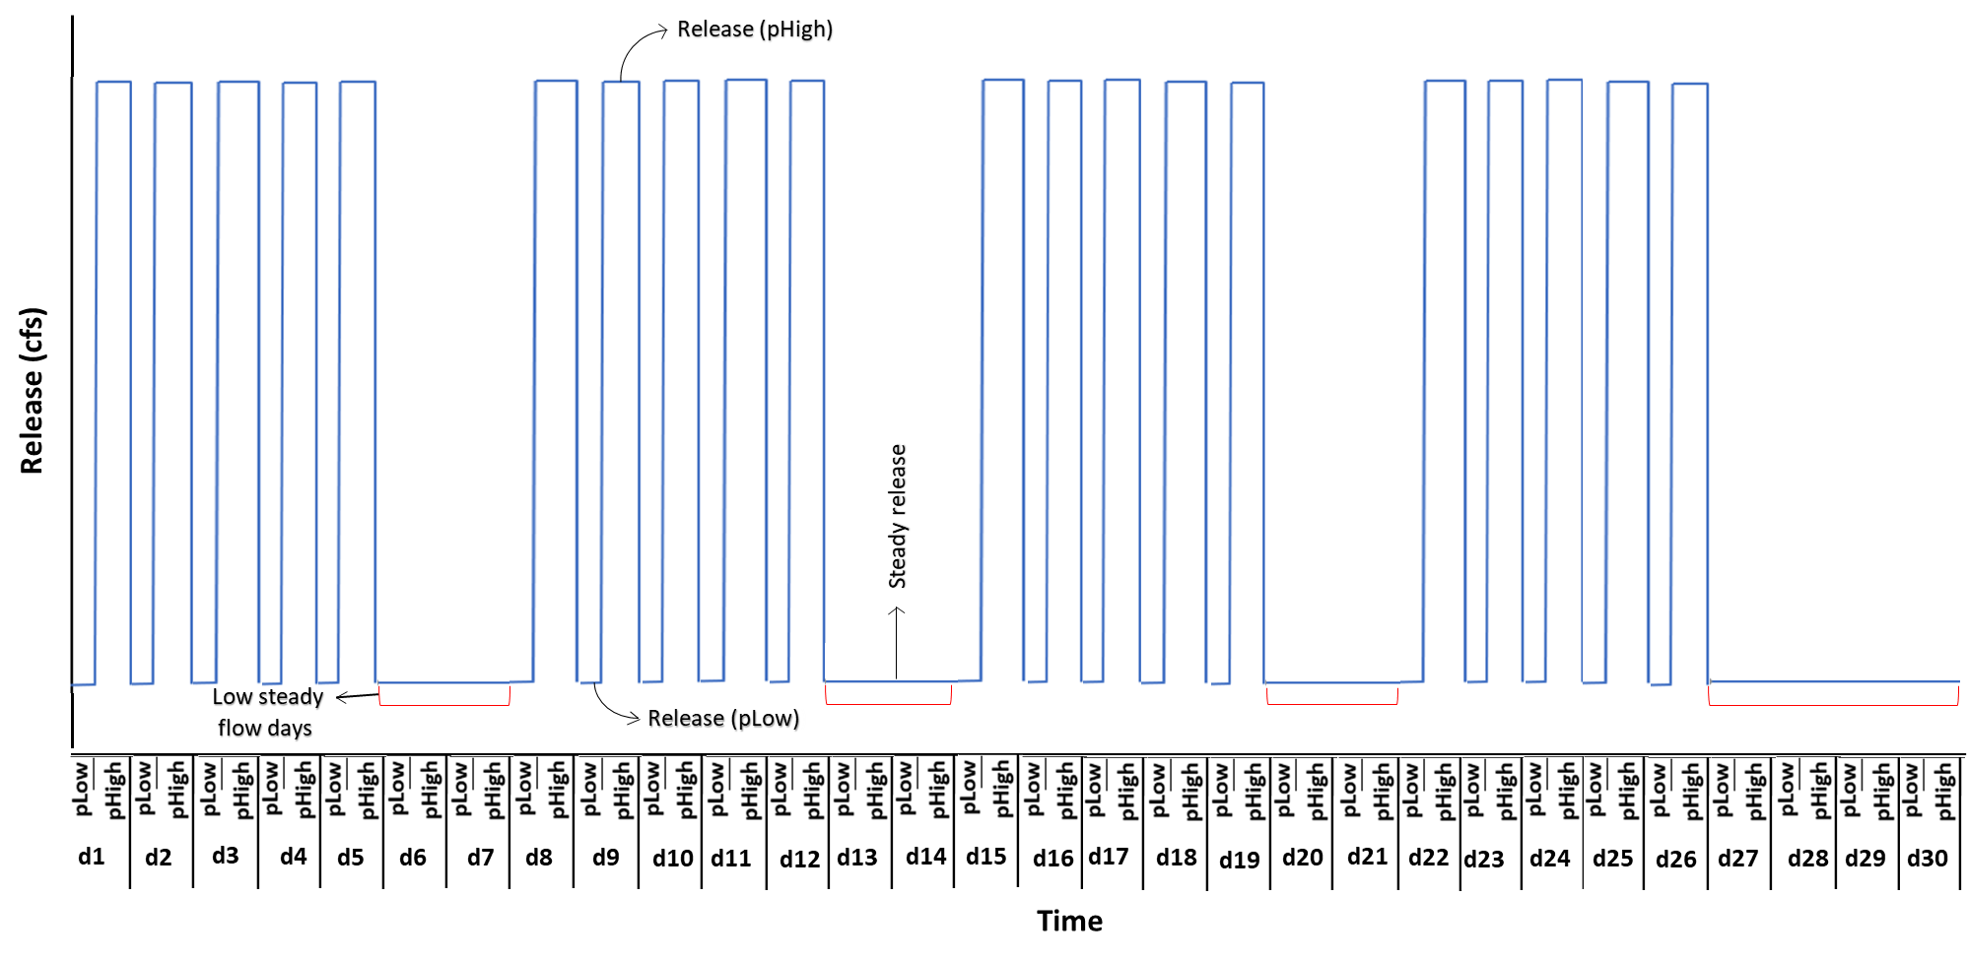The developed linear optimization model uses the constraint method to help identify the trade-off between aquatic invertebrates (i.e. number of steady low flow days) and energy revenue generation objectives. The method constrains one objective (e.g. number of steady low flow days) to a value, then maximizes the other objective (maximize the hydropower revenue). The process is repeated for different numbers of days of steady low flow. The model runs for one month with two sub-daily timesteps and is subject to daily release limits, ramp rates, maximum energy generation, storage limits, and an exogenously specified monthly release volume. For instance, the power plant at Glen Canyon dam can hold releases between 8,000 to 31,500 cfs, lake Powell has maximum storage capacity of 25 MAF, and the rate of change of release for Glen Canyon Dam was 8,000 cfs per day (LTEMP, 2016). The Appendix provides further details of the mathematical formulation.

Figure 1 Example monthly hydrograph with 10 steady low flow days. On x-axis, d1 to d30 are representing the days in a month with each day having two sub-daily periods (pLow and pHigh). The duration of pLow is assumed as 8 hours and pHigh as 16 hours. The y-axis shows release value within a period.

The model was validated against a dataset from June 2018 and was tested for scenarios that vary the total monthly flow volume between 0.7 and 1.1 million acre-feet per month, number of days of steady low flow between 0 and 30 days, and scenarios that lowered the peak price from $63.52 (base case) to $50.61 to $37.70 /MWh. In the final price scenario, the peak and off-peak prices were equal. Also, we ran the model with a scenario having same energy prices for weekday and weekend to check the sensitivity of model towards the pricing template.

We estimate the market capacity for energy generation from the slack variables associated with the constraints for either the upper limit on release or rate of change of release. We use the auto-generated shadow values (Lagrange multipliers) to describe how much hydropower revenues will change if the maximum ramp rate of 8,000 cfs/day is increased/decreased. We also use auto-generated range of basis values for that constraint to identify how much the ramp rate must increase/decrease to change the structure of the monthly release hydrograph.

**Model Validation**

Two scenarios of modeled Glen Canyon dam releases and energy generation were validated against observed values (Table 1). 15 mins observed release timeseries at Lees Ferry gage (station id: 09380000) for June 2018 was acquired from USGS Grand Canyon monitoring and research center website (<https://www.gcmrc.gov/discharge_qw_sediment/station/GCDAMP/09380000>). Daily energy generation data was acquired from United States Bureau of Reclamation website (<https://www.usbr.gov/rsvrWater/HistoricalApp.html>). Scenario#1 is the observed data. Scenario #2 presents the results of a model where 15-minute observed releases were upscaled to hourly releases and hourly energy pricing provided in WAPA document were used. Scenario#3 is the linear programming formulation for the problem with two time-periods per day that took inputs of the monthly flow volume, 9 days of steady low flow, and energy prices of $63.52/MWh & $37.70/MWh for the pHigh and pLow periods. Each price was estimated as the total revenue generated from the hourly price and release data for that period for the month divided by the number of hours in the period for the month. These prices preserved the total monthly revenue between scenarios #2 and #3.

Table 1. Validation Scenarios

|  |  |  |  |  |  |
| --- | --- | --- | --- | --- | --- |
|  | **Scenario** | **Flow volume (Ac-ft/ Month)** | **Energy generated (MWh)** | **Revenue generated ($)** | **% Error in energy generated relative to observed** |
| 1 | Observed | 784,406 | 343,202 |  |  |
| 2 | Hourly | 784,406 | 351,093 | $18,308,079 | 2.3% |
| 3 | Linear programming (2 periods: pHigh & pLow) | 784,406 | 351,093 | $18,308,092 | 2.3% |

The results in Table 1 show that both models ( hourly, and linear formulation model) generate about 2.3% more energy than observed. We looked through the elevation data of the reservoir and found that the storage level dropped by ~1.6 ft during the simulation month. That means an error of 0.2% can be expected from constant monthly head assumption. However, the main cause of energy over production can be the energy generation formula used (refer model formulation for details). The time series of energy generation for all validation scenarios can be found in appendix Figure S2, and the hydrographs for each of the scenarios are presented in appendix Figure S3.

**Results**

Figure 2 presents the calculated trade-off between the number of steady low bug flow days (i.e. ecosystem objective) and hydropower revenue. Different curves in Figure 2 are results for distinct total monthly volume scenarios. Dots on the curves are the estimated trade-off values for scenarios of different number of steady low bug flow days. Each curve in Figure 2 shows a win-win situation (i.e. increase in number of steady days increases the total revenue) as we move up from zero to eight steady low flow days (movement along y-axis). The model shows that each added steady low flow day will add almost $60,000 to the total monthly revenues.

Above 8 steady low flow days, all the curves in Figure 2 change their direction as well as slope. Now, a win-lose situation manifests -- increase in number of days of steady releases decreases revenue from hydropower generation. With each added steady day, an amount of almost $62,750 deducts from the total monthly revenues. The reason behind the direction change was the situation where the additional steady days are replacing the unsteady releases weekdays. Which means now the model has some of the weekdays on-peak releases lowered to weekend steady releases. The transition point at 8 days corresponds to the number of weekend days in the month and also represents the current practice of the bug flow experiments.

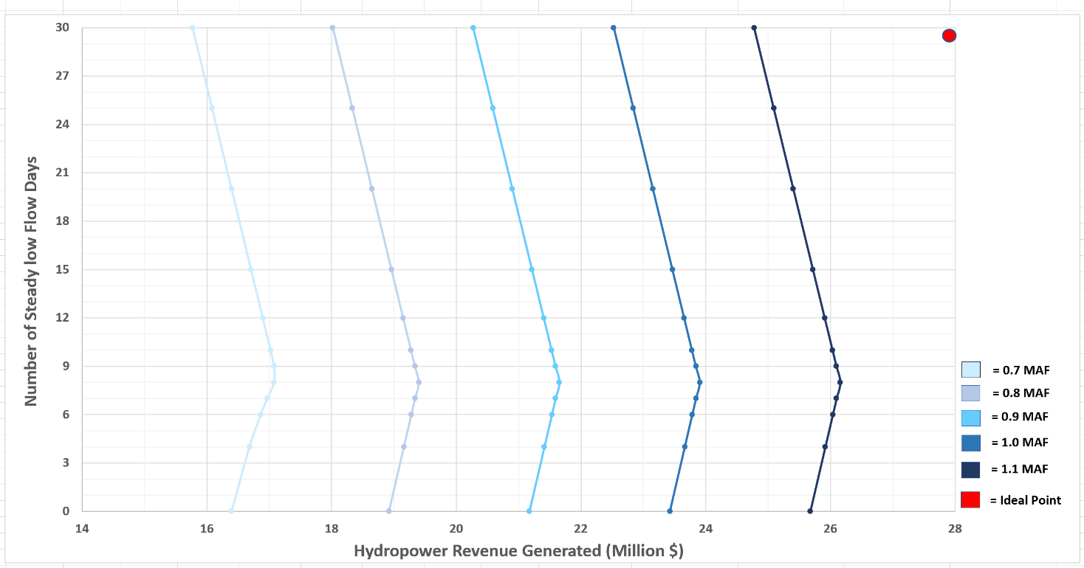In figure 2, the scenario with total monthly volume of 0.7 MAF does not follow the mentioned rates of revenue change. The reason is the rate of change of release constraint does not bind for this scenario – there is not enough water -- while the constraint binds for all other monthly volume scenarios.

Figure 2 Trade-off between Number of low flow days and Hydropower revenue. Each color is representing a specific monthly volume scenario.

Another finding from Figure 2 is that the revenue from zero steady days equals the revenue from 15 steady low flow days (20 days for the 0.7 MAF per month release scenario). Which means 15 steady low flow days will generate the same revenues as were generated before the bug flow experiments (before summer 2018).

The model produces hydrograph for each scenario of days with steady low flows (Figure 3). The hydrograph for any scenario with zero steady low flow days has consistent hydropeaking throughout the month (pre-bug flow experiments practice). The hydrograph for eight steady low flow days scenario has steady low flows on weekends and hydropeaking on weekdays (current bug flow experiment practice). The hydrographs with 30 steady low flow days scenario was flat. As the number of days of steady flow increases, the base flow also increases.

In Figure 2, it can also be noticed that increasing the total monthly release volume pushes the tradeoff curves right. Which means increasing the total monthly release volume benefit both the objectives (win-win scenario). The model estimated that each added 0.1 MAF of monthly release volume will generate $2.25 million additional revenues.

In addition, the model was tested with scenarios having different price differentials between on- and off-peak energy prices (Figure 4). By decreasing the price differentials from $25.82 (base case) to $12.91 to $0/MWH, the tradeoff curves shifted left to lower hydropower revenues. Also, decreasing the price differential between on- and off-peak prices flattens the slope of the tradeoff curves from $62,750 to $31,370 to $0 revenue per added day of steady flow. With a price differential of $0/MWh, the tradeoff curve is a vertical line. Under this price scenario, the energy revenue is the same regardless of the number of days of steady low flow and regardless of whether the hydrograph is flat or has hydropeaking.

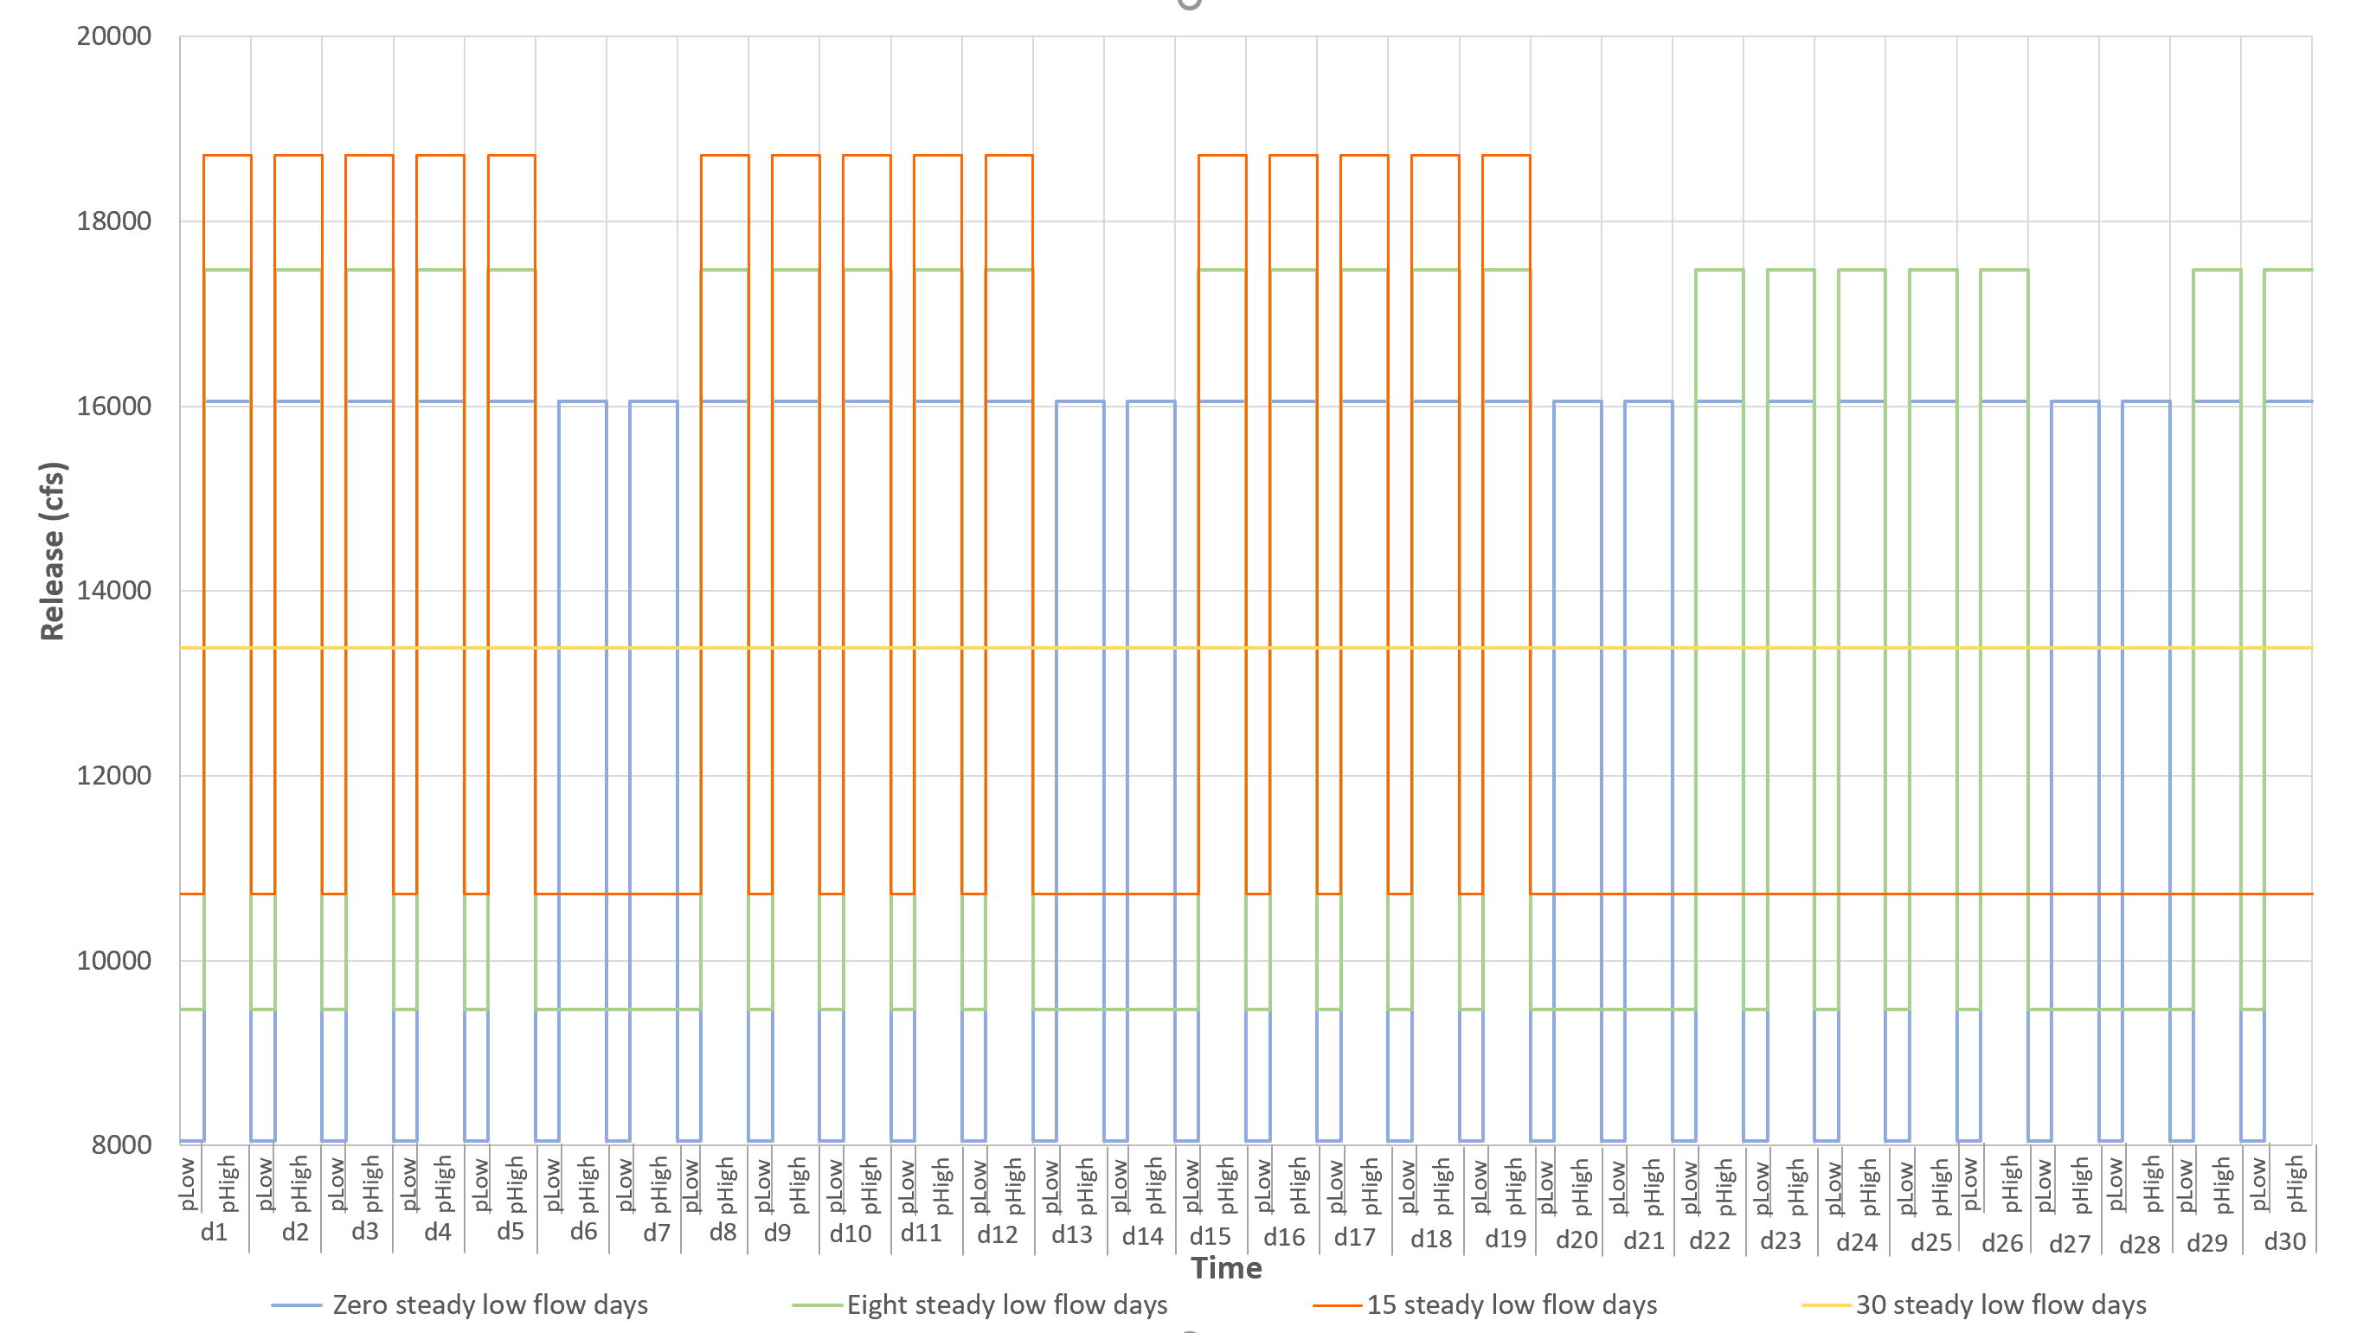

Figure 3 Monthly hydrographs for number of steady low flow days scenarios (0, 8, 15, and 30 steady days) with 0.8 MAF total monthly release volume.

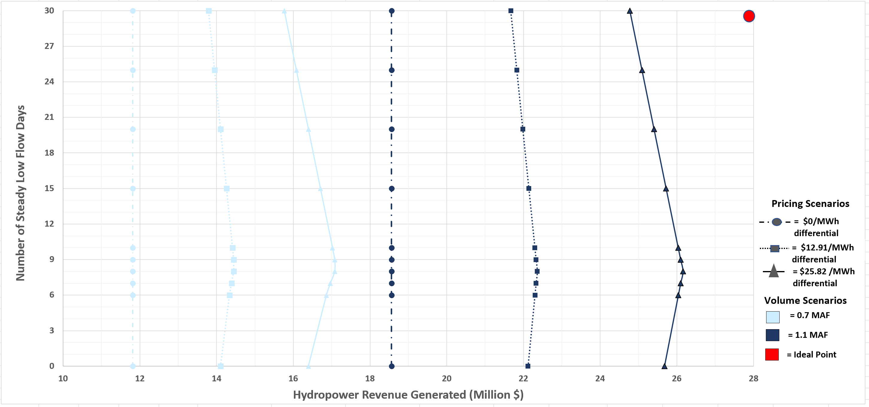

Figure 4 Tradeoff curves between Number of low bug flow days and Hydropower revenue for three scenarios of price differential scenarios. The type of line presents results of specific price differential scenario run i.e. dotted line is for 0$ price differential between on-peak and off-peak prices, dashed line is for half of current price differential ($12.91/MWh), and the solid line is for current price differential ($25.82/MWh). Different colors show specific monthly volume scenario.

In most of the scenarios, the rate of change of release constraint was binding so WAPA has no capacity to increase release during the on-peak portion of the day. However, some of the possible options to get benefit from capacity value can be: 1) Increase the rate of change of release per day. 2) Increase the off-peak releases during high market capacity days. This will give opportunity to have higher on-peak flows to generate more electricity without violating the release rate change constraint. 3) Increase on-peak release on a weekday scheduled for low flow that also has a high market capacity value. Which means convert a steady flow weekday into a hydropeaking day but at a higher energy price than usual. That change will generate additional revenue. For example, if the day-ahead capacity price is $100/MWh (Figure S1), the hydropeaking price is $63.52/MWh, and release increases by 8,000 cfs for the entire 16-hour on-peak period, 4755 additional MWh and $173,470 revenue will be generated. This additional revenue could fund two additional weekdays of low flow later in the month. The shortcoming of this approach is the difficulty in prediction of days with high market value, quickly switch releases to capitalize on very high day-ahead prices, and have a day with high prices coincide with a previously scheduled day of steady low flow.

The suggestion of the maximum 8000 cfs change in release per day was given in LTMEP (2016) to retain sediment conservation benefits as well as recreation and safety benefits. To better understand the repercussions of this constraint, we looked through the auto-generated shadow values associated with relaxing/tightening the constraint (Table 2) . It was found that the marginal values were influenced by number of steady low flow days, because increasing the number of steady days will limit the hydropeaking days. The release change limit constraint only binds on the hydropeaking days. The model estimated tradeoff values ranging from $39200 to $172600 per month of hydropower revenues with 1000 cfs change in the range of daily release (Table 2). Also, the upper limit given by the model for the constraint was ~13000 cfs without changing the solution basis. Which means there is an opportunity to increase the range of release change per day in most of the scenarios, but the ecological (e.g. sand bars, vegetation) and recreational (e.g. commercial boating, camping, and rafting) cost of that increase is unknown.

Table 1 Marginal (shadow) values for the daily rate of change of release constraint (i.e. $ per change in cfs).

Currently, the model focuses on monthly scale release decisions, but it has potential to test variety of scenarios that can guide annual scale release decisions. For example, to help identify the trade-off between ecosystem (e.g. number of steady low bug flow days), hydropower revenue, pricing, and scenarios of annual Glen Canyon Dam release volume. That trade-off can guide our selection of the months during the year to situate low flow releases that are good for aquatic invertebrates.

The model also does not consider impacts of predicted hydrographs on the important downstream ecological parameters like stream temperature, sediment transport, vegetation growth etc. Which means additional relationships can be added in the model to better connect the reservoir releases with downstream ecosystem.

**Conclusion**

This work quantifies the tradeoff between hydropower revenue and number of days of steady low flow, monthly release volumes, and difference between on- and off-peaks energy pricing. Results show that the current practice of releasing steady low flows on weekend days gives the largest hydropower revenues. Each added day of steady flow on a weekday will subtract almost $62,750 from the total benefit. However, for release volumes above 0.7 MAF per month, 15 days of steady flows would generate the same hydropower revenues as 0 days of steady flows – the regime before the start of the bug flow experiments. Increasing the monthly release volume can benefit both bug and hydropower revenue generation objectives. The price differential controls the slope of the trade-off curves. And lastly, if a market capacity event occurs during a weekday of scheduled low flows, WAPA could increase hydropower releases, and double the revenue compared to if the day had been scheduled for regular hydropeaking. The increased revenue could fund two additional days of low flows later in the month.

**Data Availability**

The input datafile, GAMS model codes, output files, and spreadsheets used during pre- and post processing can be found at: <https://github.com/moazzamalirind/linearprogramming_Bugflows>

**References**

Førsund FR. 2015. Hydropower Economics. Springer.

Hochbaum, D. S. (2007). Complexity and algorithms for nonlinear optimization problems. Annals of Operations Research, 153(1), 257–296. https://doi.org/10.1007/s10479-007-0172-6

Kennedy, T. A., Muehlbauer, J. D., Yackulic, C. B., Lytle, D. A., Miller, S. W., Dibble, K. L., Kortenhoeven, E. W., Metcalfe, A. N., & Baxter, C. V. (2016). Flow Management for Hydropower Extirpates Aquatic Insects, Undermining River Food Webs. BioScience, 66(7), 561–575. https://doi.org/10.1093/biosci/biw059

Ko, Seok-Ku, Fontane, D.G., Labadie, J.W., 1992. Multiobjective optimization of reservoir systems operation. Water Resour. Bull. 28 (1), 111–127.

Record of Decision for the Glen Canyon Dam Long-Term Experimental and Management Plan (LTEMP) Final Environmental Impact Statement (2016). https://ltempeis.anl.gov/documents/docs/LTEMP_ROD.pdf

Rheinheimer, D. E., Null, S. E., & Lund, J. R. (2015). Optimizing Selective Withdrawal from Reservoirs to Manage Downstream Temperatures with Climate Warming. Journal of Water Resources Planning and Management, 141(4), 04014063. https://doi.org/10.1061/(ASCE)WR.1943-5452.0000447

Texas Electricity Summer Rates (May 2019 Update) | ElectricityPlans.com. (2019, January 25). Electricity Plans. https://electricityplans.com/texas-electricity-rates-increase-2019/

Tilmant, A., Vanclooster, M., Duckstein, L., Persoons, E., 2002. Comparison of Fuzzy and Nonfuzzy optimal reservoir operating policies. J. Water Resour. Plann. Manage. 128, 390–398.

[USBR] US Department of the Interior Bureau of Reclamation. 2016. Glen Canyon Dam Long- Term Experimental and Management Plan Environmental Impact Statement. Refer Alternative D; page ES-33 to 34. (http://ltempeis. anl.gov/documents/draft-eis)

Yakowitz, S., 1982. Dynamic programming applications in water resources. Water Resour. Res. 18 (4), 673–696.

Yoo, J.-H. (2009). Maximization of hydropower generation through the application of a linear programming model. Journal of Hydrology, 376(1), 182–187. https://doi.org/10.1016/j.jhydrol.2009.07.026

**Appendix. Model Formulation**

This section discusses the inputs to the model, describes the parameters and decision variables used, and lists the constraints on the decision variables.

**Indices/Sets:**

d $∈$ D Days in Month: d1*d30

p $∈$ P Periods in a day: pLow & pHigh

v $∈$ tot_vol Total monthly volume scenarios: v1*v5

case $∈$ Case Defining number of steady flow days : case1*case4

**Data:**

**initstorage**  Initial storage in the reservoir (Ac-ft)

**Inflow (d)**DailyInflow to reservoir on day **d** (cfs)

**evap**  Reservoir evaporation (ac-ft per day) considered constant

throughout the month.

**EnergyRate** **(p)** Averaged energy price during period p ($ per MWH)

**Steady_Days** Number of constant flow days in the month (days)

**Decision Variables:**

**release(p)** Reservoir release at period **p** during an unsteady flow day (cfs)

**Energy_Gen(p)** Hydropower generated during the period **p** on an unsteady flow day (MWh)

**Steady_Release** Steady reservoir release during a day of constant flow (cfs)

**SteadyEn_Gen(p)** Hydropower generated during the period **p** on a steady flow day (MWh)

**Storage** Reservoir storage at the end of the month (ac-ft)

**Avail_water** Total water available in the reservoir for the month (ac-ft)

**Steady_outflow** Portion of total monthly volume released during constant flow days (ac-ft)

**Unsteady_Outflow** Portion of total monthly volume released during unsteady flow days (ac-ft)

*\**factor = conversion factor from cfs to ac-ft per hour ( i.e. 1 cfs = 0.083 ac-ft/hr)

**Constraints:**

**1) Vol_monthlyrelease** Total volume of water released in the month (ac-ft/month)

*Steady_outflow + unsteady_outflow =Vol_monthlyrelease*

**2) Reservior Mass Balance (ac-ft)**

*Storage* = *Avail_water* – *Steady_outflow* – *unsteady_outflow* – *(*evap $Totaldays)$

*

Where

*(a) Avail_water = initstorage + $\sum_{d∈D}{(inflow\left(d\right)*factor*( \sum_{p∈P}{Duration(p)}))}$*

*(b) Steady_outflow = Steady_Release $\left( \sum_{p∈P}{Duration\left(p\right)}\right)*factor* Steady_Days$

\**

*(c) unsteady_outflow = ($\sum_{p∈P}{Duration\left(p\right)}*factor*release (p))* (Totaldays-Steady_Days)$*

**3) Maximum Release limit (cfs)**

*release(p) ≤ maxRel ∀ p ∈ P*

**4) Minimum Release limit (cfs)**

*release(p) ≥minRel ∀ p ∈ P*

**5) Maximum Energy Generation limit (MWh)**

*Energy_Gen(p) ≤ 1320 × Duration(p) ∀ p ∈ P*

**6) Maximum Storage Limit (ac-ft)**

*storage ≤ maxstorage*

**7) Minimum Storage Required for Hydropower (ac-ft)**

*Storage ≥ minstorage*

**8) Ramp-up rate (cfs)**

*release("pHigh") -release("pLow") ≤ Daily_Ramprate ∀ p ∈ P*

**9) Equality Constraint (cfs)**

*Steady_Release = release(“pLow”)*

**9) Energy Generation during unsteady day (MWh)**

Energy_Gen(p)= release(p) *×* Duration(p) *×* 0.03715

**10) Energy Generation during steady day (MWh)**

SteadyEn_Gen(p)= Steady_Release *×* Duration(p) *×* 0.03715

*Note: The energy generation formula used here is provided by WAPA. Where the details about the factor involved in the formula are unknown.*

**Objective Function:**

If *Num_steady > weekends, then* maximize:

***ObjectiveVal*** *= $\left(\sum_{p∈ P}{SteadyEn_Gen(p)*weekendRate\left(p\right)}\right)*weekends+ \left(\sum_{p∈ P}{SteadyEn_Gen*weekdayRate\left(p\right)}\right)*(Steady_Days-weekends)$ $+\left(\sum_{p∈ P}{Energy_Gen(p)*weekdayRate\left(p\right)}\right)*(Totaldays-Steady_Days)$*

Else maximize:

***ObjectiveVal*** *= $\left(\sum_{p∈ P}{SteadyEn_Gen(p)*weekendRate\left(p\right)}\right)*Steady_Days+ \left(\sum_{p∈ P}{Energy_Gen(p)*weekendRate\left(p\right)}\right)*(weekends- Steady_Days)$ $+\left(\sum_{p∈ P}{Energy_Gen(p)*weekdayRate\left(p\right)}\right)*(Totaldays-weekends)$*

Where *Totaldays* = total number of days in month

*Weekends* = total number of weekend days in the month

weekdayRate(p) = Energy prices on weekday

weekendRate(p) = Energy prices on the weekend

**Energy market capacity**

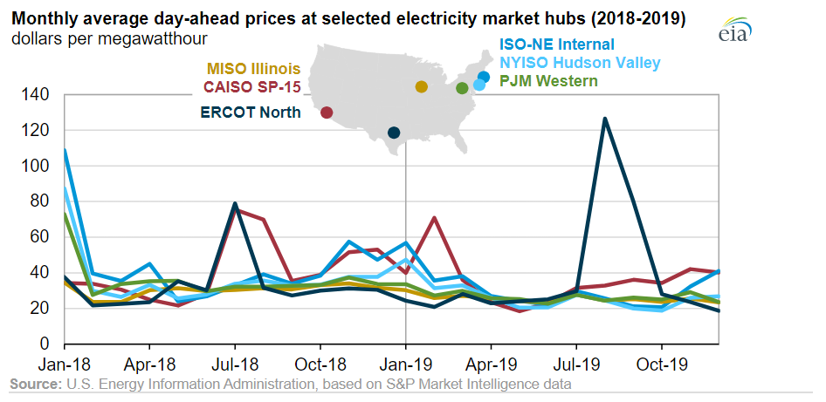

*Figure S1 Monthly electricity pricing in different US markets for years 2018-19 [Retrieved from https://www.eia.gov/todayinenergy/detail.php?id=42456]*

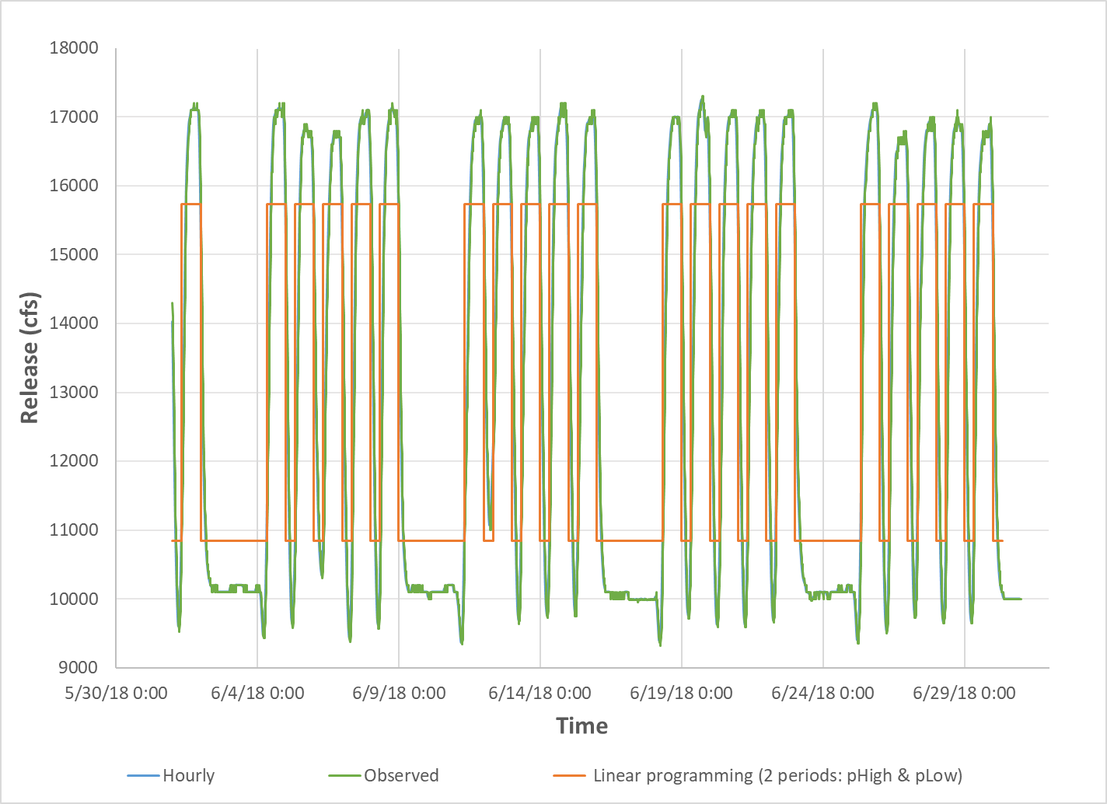**Model Validation Results**

Figure S3 Releases comparison for June 2018: Observed releases vs releases from hourly model vs releases vs releases from linear model. Here, observed release and hourly hydrographs overlap.

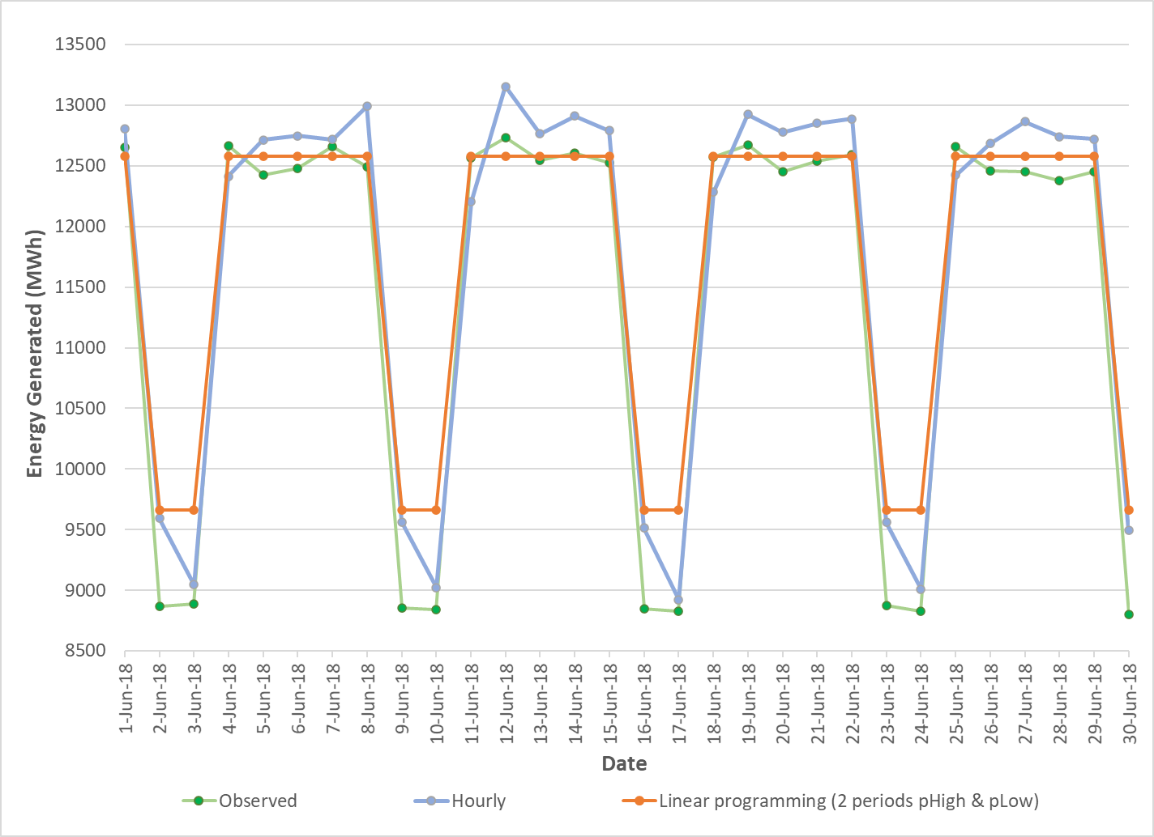

Figure S2 Daily energy generation comparison: observed energy amount vs energy generated from hourly model vs energy generated from linear model.